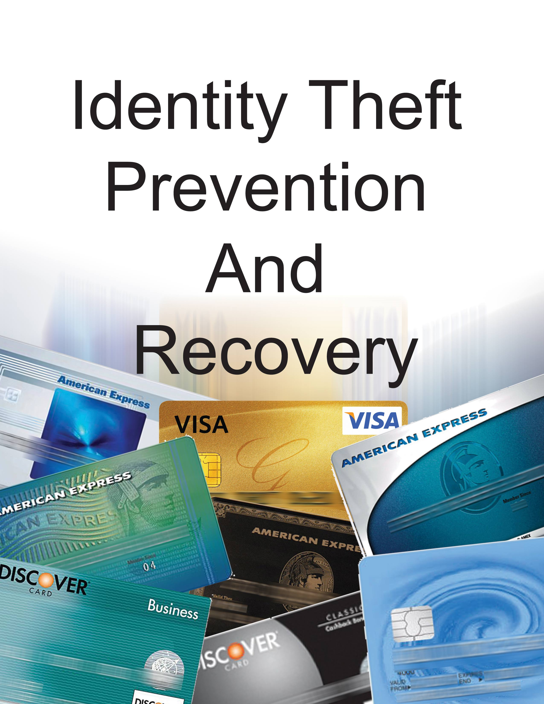

Written by Bob Pearce
CA Licensed Private Investigator - CA PI-23161
www.bobpearce.com
investigations@bobpearce.com
(661) 400-3813
The following material was taken from the course materials that accompany Mr. Pearce’s course on Identity Theft Protection & Recovery. The course is offered at junior colleges and high school level adult education classes in the Southern California area. Private group presentations or copies of his class on CD-ROM are available by contacting Mr. Pearce at contact information listed above.

Security Freeze & Fraud Alert Work Package
Step 1, Pick up the telephone a place a fraud alert of your credit profile
Step 2, Fill out and mail the letters to the credit report agencies requesting a security freeze
Step 3, Sit back and relax, knowing you have taken the single biggest step in ID Theft Prevention

Disclaimer
The information contained in this course on Identity Theft is educational and intended for informational purposes only. It does not constitute legal advice as the instructor is not an attorney, and does not represent that legal advice of any kind. The instructor is a licensed private investigator and has dealt with identity theft issues. The opinions expressed by the instructor are solely the opinions of the instructor. Furthermore, the instructor does not hold himself out to be bondable credit repair agency or service.
While much of the information provided in this course is about legal issues, it does not constitute the practice of law and should not be relied upon as such. The law changes rapidly and can differ greatly from jurisdiction to jurisdiction. Even similar laws can be interpreted differently by different courts or different jurisdictions. Bob Pearce disclaims all liability of any kind arising from the use, or misuse, of the information contained and referenced herein. Although the instructor tries to keep up with changes in laws and procedures, he does not accept responsibility for accuracy or any errors or omissions due to changes in laws and policies. If you have specific questions, please seek legal counsel to assist you with your concerns.

A fraud alert is a flag placed on your credit profile or credit history by contacting one of the three major credit reporting agencies (CRA’s). The Fraud Alert notifies potential creditors or anyone looking at your credit history, that they must use reasonable policies and procedures; to verify your identity before they issue new credit in your name.
A fraud alert may stop someone from opening new credit in your name; however it may not prevent the misuse of your existing credit. Under the Fair Credit Reporting Act (FCRA) you are entitled to two kinds of fraud alerts: initial and extended. The initial alert is good for 90 days and then expires. The extended alert requires that you send a law enforcement report of your identity theft to the credit reporting agencies and is good for about seven years. But, you won’t need the extended fraud alert, because you are going to initiate a Security Freeze on your credit history and lock it down.
If you think you are about to become a victim of Identity Theft, because your purse or wallet was stolen or lost, you would place an initial fraud alert on your credit profile. The initial fraud alert is only good for 90 days. Notify any one of the three credit reporting agencies (CRAs) and the CRA you contact, will contact the other two for you.
I want you now, to pick up the telephone, and place a fraud alert on any and everyone’s social security number you plan to place a security freeze on – explained below. This will buy you time until you can fill out and mail your letters requesting a security freeze. Note: Some of the CRA’s are working to allow you to place a security freeze via their website. You will have to check each CRA for this capability in lieu of sending them the form letter in this work packet.
Contact the Fraud Victim Departments as follows:
Equifax: (800) 525-6285
Experian (888) 397-3742
TransUnion (800) 680-7289
At the time you file a fraud alert, you are entitled to one free credit report from each of the three CRAs. As time passes and if you were actually to become a victim of Identity Theft, you would could go ahead and request an Extended Fraud Alert. However, filing this extended alert is not necessary as you plan to skip ahead and lock down your credit profile or credit history with a security freeze which has no pre-conditions that must be met as with an extended fraud alert. This added level of security requires the merchant who is requesting your credit history be in possession of a PIN and or password to unlock it - a PIN and/or password that only you possess.
For those of you in the United States Military, if you are going to be employed away from your active duty station and you don’t expect to need new credit while you are away, consider placing an Active Duty Alert on your credit Report. It is effective for 1 year unless you ask for it to be removed sooner. But as I mentioned earlier, this is just to buy time until you have time to fill out and mail your letters requesting a security freeze.
So how do we place a security freeze on our credit history? Take the letters found in this publication, fill them out and mail them into the credit bureaus along with the documentation you specify in the letter. It is that simple.
The letter is a simple fill in the blanks letter prepared in advance. Why bother to freeze your credit history? To restrict companies from granting your look-a-like (impostor) new or extended credit to buy big ticket items with your good credit.
How does a security freeze work? With a security freeze, we set up a situation where they (the credit grantors) need a user I.D. and or a PIN number provided by you and only you to bring up your credit history or credit profile on their computer. And without seeing your credit history they will be very, very reluctant to grant/extend credit for big ticket purchases to you or your impostor (a person who practices deception under an assumed character, identity), particularly in today's tight credit markets.
Does my spouse have to send the same letter to all three credit reporting agencies in order to have their file frozen too? YES. Remember, 2 people in the household (husband and wife), 3 credit bureaus = 6 letters. If you’re single, it’s only 3 separate letters at $10 per letter and if you have a significant other, its 6 letters, and two letters per each of the three credit bureaus.
Remember your “Look-A-Like” imposter will not have this secret PIN! So he or she will not be opening or extending credit in your name. If you have already become a victim of identity theft here in California, you are entitled to a FREE security freeze from the Big 3 credit bureaus. If they balk, refer them To “The California Civil Code SS 1785.11.2 to 1785.11.6.
Remember I said a security freeze means your credit file cannot be seen by potential creditor(s), well that is almost true. The credit history industry left a few holes in the Fair Credit Reporting Act legislation big enough to drive their trucks through. They can still see your credit profile to mail out new offers of credit to your home, providing you do not opt out of their marketing plans. Also, your existing creditors can always see your credit profile.
Credit bureaus must place the freeze no later than 5 business days after receiving your request. They have 3 business days in which to lift a security freeze at your request. However, do not expect to receive any correspondence that your security freeze is in effect for about 4 to 6 weeks. While your security freeze is in effect, new creditors cannot see your credit score either - which also means no new credit for you without the secret PIN and or password. Do not ever use your mother-in-law’s maiden name for an easy to remember password.
And lastly, make multiple copies of this information packet and give them to your family & friends.

Security Freeze Instructions On-Line at Equifax
www.freeze.equifax.com/Freeze/jsp/SFF_PersonalIDInfo.jsp

Security Freeze Instructions On-Line at TransUnion
www.transunion.com/corporate/personal/fraudIdentityTheft/fraudPrevention/securityFreeze.page

Security Freeze Instructions On-Line at Experian
www.experian.com/consumer/help/states/ca.htmll

Security Freeze Letter – Equifax

Date:
Equifax Security Freeze
P.O. Box 105788
Atlanta, GA 30348

Dear Equifax:
I would like to place a security freeze on my credit file.
My full name is:
My current home address is:
My former home address is:
My Social Security number is:
My date of birth is:
As a proof of residence, I have enclosed a copy of my ____________ utility bill from ____________ (Date on Bill)
I will pay the fee of $10 for placing the freeze by check number __________.
Yours truly,

Sign Here ____________________
Your Name
Your Address
Your Home Phone
Your Work Phone
Security Freeze Letter – Experian
Date:
Experian Security Freeze
P.O. Box 9554
Allen, TX 75013
Dear Equifax:
I would like to place a security freeze on my credit file.
My full name is:
My current home address is:
My former home address is:
My Social Security number is:
My date of birth is:
As a proof of residence, I have enclosed a copy of my ____________ utility bill from ________________ (Date on Bill)
I will pay the fee of $10 for placing the freeze by check number __________.
Yours truly,

Sign Here ____________________
Your Name
Your Address
Your Home Phone
Your Work Phone

Security Freeze Letter – Trans Union

Date:
Trans Union Security Freeze
P.O. Box 6790
Fullerton, CA 92834-6790

Dear TransUnion:
I would like to place a security freeze on my credit file.
My full name is:
My current home address is:
My former home address is:
My Social Security number is:
My date of birth is:
As a proof of residence, I have enclosed a copy of my ____________ utility bill from ____________ (Date on Bill)
I will pay the fee of $10 for placing the freeze by check number __________.
Yours truly,

Sign Here ____________________
Your Name
Your Address
Your Home Phone
Your Work Phone

Last Page of Security Freeze & Fraud Alert Work Package

