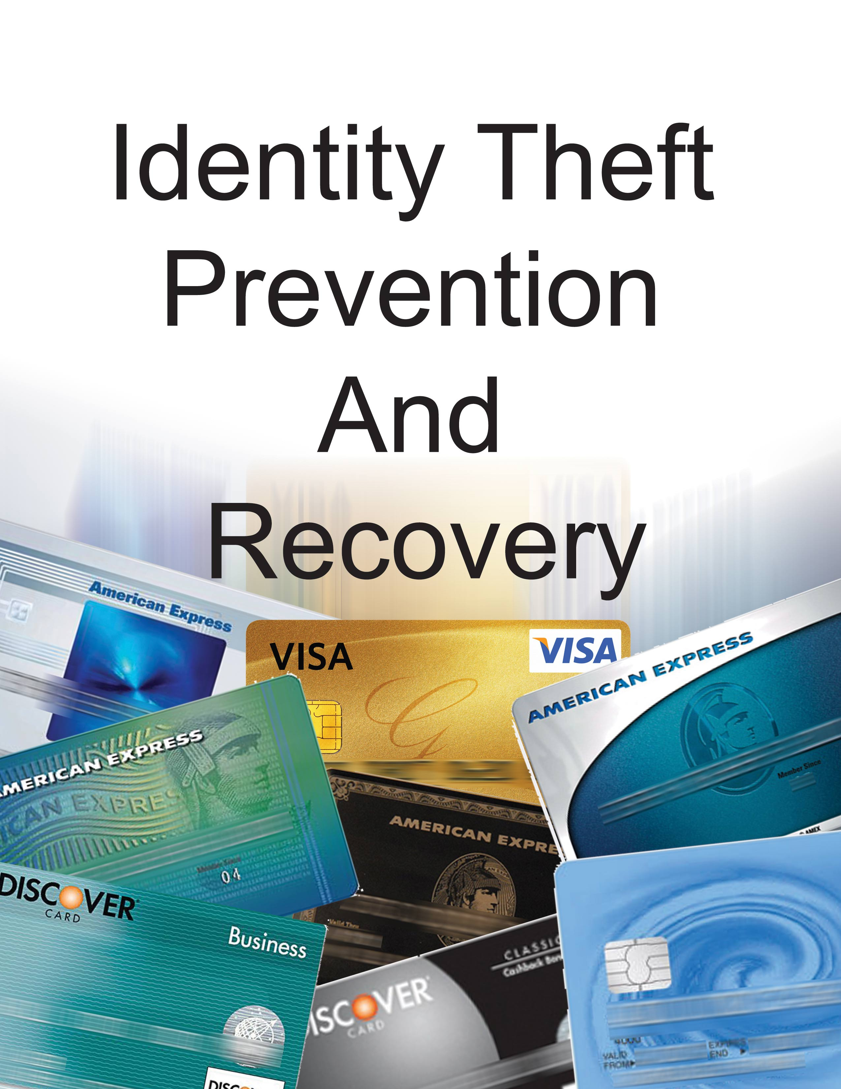

Written by Bob Pearce. CA PI-23161
CA Licensed Private Investigator
www.bobpearce.com
info@bobpearce.com
(661) 400-3813

What materials are provided with this course?
What is on Your CD-ROM and/or in Your textbook

- Notes from the power point presentation: Open the index.htm file in the class notes folder

- Appendix to the Class Notes, which contains the following
Cheat Sheet
How to Read Your Credit Report
Sample Credit Report
Personal Identifiers
ID Theft Affidavit
Annual Credit Report Request
Sample letter to freeze your credit report
Sample Dispute Letter - Big 3 Credit Reporting Agencies
Sample Blocking Letter - Consumer Reporting Company

- A folder of Government Publications. In Adobe PDF format
- A folder of MS Word Files, in Microsoft Word 2007 format

Disclaimer

The information contained in this course on Identity Theft is educational and intended for informational purposes only. It does not constitute legal advice the instructor is not an attorney, and does not represent that he is giving legal advice of any kind. The instructor is a licensed privacy investigator and has dealt with identity theft issues. The opinions expressed by the instructor are solely the opinions of the instructor. Furthermore, the instructor does not hold himself out to be bond able credit repair agency or service
While much of the information provided in this course is about legal issues, it does not constitute the practice of law and should not be relied upon as such. The law changes rapidly and can differ greatly from jurisdiction to jurisdiction. Even similar laws can be interpreted differently by different courts or different jurisdictions. Bob Pearce disclaims all liability of any kind arising from the use of, or misuse, of the information contained and referenced herein. Although the instructor tries to keep up with changes in laws and procedures, he does not accept responsibility for accuracy or any errors or omissions due to changes in laws and policies. If you have specific questions, please seek legal counsel to assist you with your concerns.

Table of Contents
Identity Theft Protection & Recovery

Chapter 1 – Introduction
How to order your credit report from the Credit Reporting Agency designated web site. Learn how to order over the internet, my mail or by phone for FREE. Learn about two vitally import books. There is one book on ID Theft protection and one book on ID Theft recovery. What materials are included in the course?
  - Textbook (optional)
  - CD-ROM
    - Class notes in the form of a web page, no note taking required
    - Folder of Government Publications
    - Blank letters to freeze your credit profile for 5 years
  - Class Handouts
  - Laminated examples

Chapter 2 – What is Identity Theft
What is Identity Theft? What exactly is it that is stolen. Why would someone want to steal my identity? How do I know it has been stolen? More importantly, what do I do if it has been stolen? What do I do first? What are we talking about when we mention “Personal Identifiers?”
Chapter 3 – The Law is on Your Side
Chapter 3 examines the California Penal Codes. Specifically - what type of activities are deemed illegal. We see special consideration given to crimes involving elders & dependent adult. The California database for identity theft victims is created.
Chapter 4 - How do You Know When You Have Become a Victim?
Learn the subtle clues of identity theft. What we mean by the term personal identifiers. The one book every victim should own. In chapter 4 you learn the tell tale signs that your identity has been stolen.
Chapter 5 – What’s Required is a New Mental State of Mind
In the year 2009 you will learn and develop new skills for fighting back against Identity Theft. Learn how to identify phishing emails for what they are. Here you will learn about new behavior patterns to incorporate into your “self” Links for encryption software and much more.
Chapter 6 - Steps to Minimize Your Exposure to ID Theft
Take concrete steps to minimize your exposure to Identity Theft. Recognize our world today is not the same one we were born into. Learn specific behaviors to implement now and forever more.

Chapter 7 - What to do If You Do Become a Victim of Identity Theft
Time is of the essence when you become a victim of ID Theft. What are the important first steps to take? Learn about the “Fraud Alert.” How to place one and what it accomplishes. The one book every victim should own. Proving you are a victim and your “Certificate of Innocence”
In chapters Chapter 8 – 24 you learn, specifically, how to handle the various form of Identity Theft:
8. Bank Accounts & Fraudulent Withdrawals
9. Fraudulent Electronic Withdrawals
10. Fraudulent New Accounts
11. Federal Reserve System
12. Bankruptcy Fraud
13 Correcting Fraudulent Information in Credit Reports
14. Credit Cards
15. Criminal Violations
16. Debt Collectors
17. Driver's License
18. Investment Fraud
19. Mail Theft
20. Passport Fraud
21. Phone Fraud
22. Social Security Number Misuse
23. Student Loans
24. Tax Fraud
Chapter 25 – the Fair Credit Reporting Act or (FRCA)
Your rights under the FRCA & the Electronic Funds Transfer Act or (EFTA). The National Specialty Consumer Reporting Firms. Who are they, what do they report.

Insert printed copies of the following html files (a file you open with an internet browser) here, where you find this page:

1. Open the index.htm file in the class notes folder of your CD-ROM using your internet browser print this file out

2. Open the Equifax Tutoria.htm file in the class notes folder of your CD-ROM using your internet browser print this file out.

3. Open this Experian Tutorial.htm file in the class notes folder of your CD-ROM using your internet browser print this file out.

4. Open the TransUnion-Tutorial.htm file in the class notes folder of your CD-ROM using your internet browser print this file out.

5. Open the Glossary of Terms.htm file in the class notes folder of your CD-ROM using your internet browser print this file out.

Put the above html files HERE!

Appendix
Cheat Sheet
How to Read Your Credit Report
Sample Credit Report
Personal Identifiers
ID Theft Affidavit
Annual Credit Report Request
Sample letter to freeze your credit report
Sample Dispute Letter - Big 3 Credit Reporting Agencies
Sample Blocking Letter - Consumer Reporting Company

Cheat Sheet
Modifying Your Behaviors
Just Once
- Pick up the phone and file a fraud alert on your social security number / credit profile
- The Security Freeze. Take the letters found on your CD-ROM, under the MS Word files, and fill them out on your computer or fill them out by hand and mail them to the credit bureaus. Do not forget your spouse is or significant other’s credit profile
- Tear up your debit cards
- Buy and use a paper shredder
- Photocopy all your credit cards front and back
- Every computer in your home should have a good firewall and virus protection program
- Take any Personal Identifiers off your printed checks
- Take your social security card out of your purse or wallet
- Ask your financial institutions to add extra security protection to your account – add a password to your accounts
- Purchase encryption software for home use.
- Remove your name from the marketing lists of the three credit reporting bureaus, call 888-5OPTOUT, or go online to www.optoutprescreen.com.
- Sign up for the Federal Trade Commission's National Do Not Call Registry, (888) 382-1222 or at www.donotcall.gov
- Sign up for the Direct Marketing Association's Mail Preference Service, Mail Preference Service, PO Box 643, Carmel, NY 10512 (Include $1 check or money order.) or opt-out online: https://www.dmachoice.org/dma/member/regist.action. A credit card is required for verification only. There is no fee for opting out online.
- Install a locked mailbox at your residence to deter mail theft.
- Convert as much bill-paying as you can to automatic deductions from your checking account and/or credit account.
- Stop using file-sharing and file-swapping programs – i.e. downloading music.
- Reduce the total number of credit cards you carry in your purse or wallet.
- Register your cell phone for the do not call list. 888 382-122
- Password protect all your computers
- To rid your PC of spyware and pop-up adware, download free software called Spybot. You can get this at ..www.download.com at no cost.
- There is also SpyCop ..(www.spycop.com), which will alert you if you’re being .watched or if key-logging programs are on your computer.
- To rid yourself of pop-ups or adware use www.ada-ware.com
- Think about using a anonymous Internet connection. You may wish to use anonymiser software. Go to ..www.anonymiser.com

Yearly
- Review your credit reports every 4 months for free
- Order your Earnings and Benefits Statement from the Social Security Administration at 800 772-1213 or www.ssa.gov,
- Don’t write down your passwords, especially on your computer. If you do store them on your computer, use encryption

Monthly
- Review the links provided in your material occasionally. Visit one new site a week
- Each month, carefully review your credit card, bank and phone statements, including cellular phone bills, for unauthorized use.

Daily
- Practice more vigilance every day
- Consider using a gel pen for writing checks
- Learn how to read and decipher your credit report

As Needed
- Before disposing of your computer, remove data by using a strong "wipe" utility program
- Do not toss pre-approved credit offers in your trash or recycling bin without first tearing them into very small pieces or shredding them with a cross-cut shredder.
- Don’t just give your old computer away when you purchase a new one, at least not until you have time to erase the hard drives. Use hard drive eraser software from: www.east-tec.com
- Change passwords on a regular basis. Use different passwords on different accounts. Do not type passwords on computers you do not control
- Back up your data before you leave for your trip.
- If you travel for business, make sure that the personal and private information on your laptop is password protected and contained in encrypted files.
- Don’t stop your mail or your newspaper when traveling, have a friend pick it up every day.

And if you do become a victim (in general terms)
- Step Zero - Buy this book if you have been the victim of Identity Theft. “From Victim to Victor.” By attorney Mari Frank at PORPOISE PRESS, INC.(800) 725-0807 or visit www.identitytheft.org
- First call one of three Credit Bureaus and place a Fraud Alert - Equifax: 800 525-6285, or Experian: 888 397-3742 or TransUnion:800 680-7289
- Secondly, you will close out all affected accounts and get new account numbers
- Third, call your Local Law Enforcement and file an Identity Theft Report.

And if you do become a victim (in general terms - continued
- Next, check with your bank in the event your checks are stolen & look for fraudulent use or fraudulent accounts that you did not open.
- Also, do not forget to contact your utility companies, and make sure no changes have been made.
- Call the post office and inquire if a change of address was filed.
- Call all of your other credit issuers and have your accounts password protected.
- If you haven’t already, fill out the form letters to freeze your credit profile.
- Then close the accounts that you know, or believe have been tampered with or opened fraudulently.

Specific Instructions for Specific Circumstances of Identity Theft
Bank Accounts & Fraudulent Withdrawals
- Generally speaking, you have 60 days from the date your bank account statement is sent to you to report in writing any money withdrawn from your account without your permission
- If your ATM or debit card is lost or stolen, report it immediately because the amount you can be held responsible for can depend on how quickly you report the loss.
- Call the financial institution and follow up in writing - by certified letter, return receipt requested - so you can prove when the institution received your letter.
- For more information, see Electronic Banking and Credit, ATM and Debit Cards: What To Do If They're Lost or Stolen at www.consumer.gov/idtheft
Fraudulent Electronic Withdrawals
- If an identity thief steals your checks or counterfeits checks from your existing bank account, stop payment, close the account, and ask your bank to notify the Chex Systems, Inc., or the check verification service it uses.
- You may be held responsible for the forgery if you fail to notify the bank in a timely manner that a check was lost or stolen.
- You can contact major check verification companies directly and, request that they notify retailers who use their databases not to accept your checks.
- Global Payments:(800) 766-2748
Chex System: (800) 428-9623
Cross Check: (800) 843-0760
Equifax Check: (800) 437-5120
SCAN: (800) 262-7771
Tele Check: (800) 710-9898
International Check (800) 526-5380
- The merchant who rejects your check should give you its check verification company contact information so you can find out what information the thief is using. If you find that the thief is using your MICR code, ask your bank to close your checking account, and open a new one.

Fraudulent Electronic Withdrawals - continued
- If the checks are being passed on a new account, contact the bank to close the account. Also contact Chex Systems, Inc., to review your consumer report to make sure that no other bank accounts have been opened in your name.
- Dispute any bad checks passed in your name with merchants so they don't start any collections actions against you.
Fraudulent New Accounts
- If you have trouble opening a new checking account, it may be because an identity thief has been opening accounts in your name.
- Chex Systems, Inc., produces consumer reports specifically about checking accounts.
- You can request a free copy of your consumer report by contacting Chex Systems, Inc.
- If you have trouble getting a financial institution to help you resolve your banking-related identity theft problems, including problems with bank-issued credit cards, contact the agency that oversees your bank.
- If you're not sure which of these agencies is the right one, call your bank or visit the National Information Center of the Federal Reserve System at www.ffiec.gov/nic/ and click on “The Institution Search” link.
- Federal Deposit Insurance Corporation (FDIC) - www.fdic.gov The FDIC supervises state-chartered banks that are not members of the Federal Reserve System, and insures deposits at banks and savings and loans.
- Call the FDIC Consumer Call Center toll-free: 1-800-934-3342; or write: Federal Deposit Insurance Corporation, Division of Compliance and Consumer Affairs, 550 17th Street, NW, Washington, DC 20429.
www.fdic.gov/consumers/consumer/news/cnfa1l97/wallet.html

Federal Reserve System
- The United States Federal Reserve can be found at- www.federalreserve.gov . The Fed supervises state-chartered banks that are members of the Federal Reserve System. Call: 202-452-3693; or write:

- Division of Consumer and Community Affairs
Mail Stop 801
Federal Reserve Board
Washington, DC 20551
- The NCUA charters and supervises federal credit unions and insures deposits at federal credit unions and many state credit unions. Call: 703-518-6360; or write: Compliance Officer, National Credit Union Administration, 1775 Duke Street, Alexandria, VA 22314.
- The OCC charters and supervises national banks. If the word “National Bank,” appears in the name of a bank, or the initials follow its name, the OCC oversees its operations. Call toll-free: 1-800-613-6743 (business days 9:00 a.m. to 4:00 p.m. CST); fax: 713-336-4301; or write: Customer Assistance Group, 1301 McKinney Street, Suite 3710, Houston, TX 77010.
- The OTS is the primary regulator of all federal, and many state-chartered, thrift institutions, including savings banks and savings and loan institutions. Call: 202-906-6000; or write: Office of Thrift Supervision, 1700 G Street, NW, Washington, DC 20552.

Bankruptcy Fraud
- If you believe someone has filed for bankruptcy in your name, write to the U.S. Trustee in the region where the bankruptcy was filed. A list of the U.S. Trustee Programs' Regional Offices is available on the UST website, or check the Blue Pages of your phone book under U.S. Government Bankruptcy Administration.
- In your letter, describe the situation and provide proof of your identity. The U.S. Trustee will make a criminal referral to law enforcement authorities if you provide appropriate documentation to substantiate your claim.
- You also may want to file a complaint with the U.S. Attorney and/or the FBI in the city where the bankruptcy was filed. The U.S. Trustee does not provide legal representation, legal advice, or referrals to lawyers.
- Bankruptcy fraud means you may need to hire an attorney to help convince the bankruptcy court that the filing is fraudulent
- Request that the bankruptcy court include in its order of dismissal facts that will help you repair your credit, including a statement that you did not file this bankruptcy case and that the case was filed by an imposter as the result of identity theft.
- Ask the bankruptcy court to send a copy of the dismissal order to each consumer reporting company; if the court will not do so, you should send the order to the consumer reporting companies yourself.
Correcting Fraudulent Information in Credit Reports
- Under the FCRA, both the consumer reporting company and the information provider (the business that sent the information to the consumer reporting company), such as a bank or credit card company, are responsible for correcting fraudulent information in your report.
- To protect your rights under the law, contact both the consumer reporting company and the information provider.
- Consumer Reporting Company obligations: reporting companies will block fraudulent information from appearing on your credit report if you take the following steps: Send them a copy of an identity theft report and a letter telling them what information is fraudulent.
- The letter also should state that the information does not relate to any transaction that you made or authorized. In addition, provide proof of your identity that may include your SSN, name, address, and other personal information requested by the consumer reporting company.
- The consumer reporting company has four business days to block the fraudulent information after accepting your identity theft report. It also must tell the information provider that it has blocked the information.
- There is a LINK to a sample Blocking Letter to a Consumer Reporting Agency in your class notes
Credit Cards
- The Fair Credit Billing Act limits your liability for unauthorized credit card charges to $50 per card.
- However you must write to the creditor at the address given for “billing inquiries”
- Mail your letter so that it reaches the creditor within 60 days after the first bill containing the error was mailed to you
- If an identity thief changed the address on your account and you didn't receive the bill, your dispute letter still must reach the creditor within 60 days of when the creditor would have mailed the bill.
- You should send your letter by certified mail, and request a return receipt. It becomes your proof of the date the creditor received the letter. Include copies of your police report or other documents that support your position.
- The creditor must acknowledge your complaint in writing within 30 days after receiving it, unless the problem has been resolved.
- The creditor must resolve the dispute within two billing cycles (but not more than 90 days) after receiving your letter.
To be complete by the student, if needed
Criminal Violations
Debt Collectors
Driver's License
Investment Fraud
Mail Theft
Passport Fraud
Phone Fraud
Social Security Number Misuse
Student Loans
Tax Fraud
The Fair Credit Reporting Act or (FRCA)

Personal Identifiers include, but are not necessarily limited to the following:
- Name, first, last, middle name
- Your Social Security Number
- Date of birth
- Home addresses(s)
- Place of employment
- Work and home phone numbers
- The name of your bank or savings or loan,
- The PIN number to one or more of your cards
- Property you own, cars, boats planes, homes, etc.,
- Your voice print as recorded
- Your physical appearance: height, height, build, tattoos
- Credit card numbers
- Any and all personal identification numbers (PIN’s)
- Any and all passwords or user names
- Alien registration numbers
- United States or other country passport numbers
- School identifications number
- Health insurance / dental insurance identification numbers
- State or federal drivers license numbers
- Your employee number if you work outside the home.
- Professional or occupation numbers
- Telephone numbers: land line, cell and FAX numbers
-Ham Radio call sign numbers and letters
- Mother’s maiden name
- Checking and Savings (demand) account numbers
- Any financial asset account numbers i.e. brokerage account numbers
_____________________________
Name_________________________ Phone Number__________________ Page 1

ID Theft Affidavit
Victim Information
_________________________________________________________________________
(First) (Middle) (Last)

(2) (If different from above) When the events described in this affidavit took place, I was known as:
_________________________________________________________________________
(First) (Middle) (Last)

(3) My date of birth________________________________
(day/month/year)

(4) My Social Security number is, ______________________________________

(5) My driver's license or identification card ______________________________

(6) My current address_______________________________________________
City State Zip Code ______________________________________________________

(7) I have lived at this address since _______________________________________ (month/year)

(8) (If different from above) When the events described in this affidavit took place, my …...address was:

City, State________________________________Zip Code ______________

(9) I lived at the address in Item 8 from______________until_________(month/year)
(10) My daytime telephone number is(_______)___________________________

My evening telephone number is (_______)______________________________

DO NOT SEND AFFIDAVIT TO THE FTC OR ANY OTHER
GOVERNMENT AGENCY

Name___________________________ Phone Number_______________ Page 2

How the Fraud Occurred, Check all that apply for items 11 - 17:

(11) ___I did not authorize anyone to use my name or personal information to seek the money, credit, loans, goods or services described in this report.

(12)___ I did not receive any benefit, money, goods or services as a result of the events described in this report.

(13)____My identification documents (for example, credit cards; birth certificate; …………driver's license; Social Security card; etc.] were stolen lost on or about

(14)___ To the best of my knowledge and belief, the following person(s) used my information (for example, my name, address, date of birth, existing account numbers, Social Security number, mother's maiden name, etc.) or identification documents to get money, credit, loans, goods or services without my knowledge or authorization:

______________________________ ______________________________
Name (if known) Name (if known)

______________________________ ______________________________
Address (if known) Address (if known)

______________________________ ______________________________
Phone number(s) (if known) Phone number(s) (if known)

______________________________ _______________________________
Additional Information (if known) Additional Information (if known)

(15)___ I do NOT know who used my information or identification documents to get money, credit, loans, goods or services without my knowledge or authorization.

(16)____ Additional comments: (For example, description of the fraud, which documents or information were used or how the identity thief gained access to your information.)

(Attach additional pages as necessary)

DO NOT SEND AFFIDAVIT TO THE FTC OR ANY OTHER
GOVERNMENT AGENCY

Name__________________________ Phone Number_________________ Page 3
Victims Law Enforcement Actions

(17) (check one) ____am ____ am not willing to assist in the prosecution of the person(s) who committed this fraud.

(18) (check one) ____am ____am not authorizing the release of this information to Law enforcement for the purpose of assisting them in the investigation and prosecution of the person(s) who committed this fraud.

(19) (check all that apply) ____have ____ have not reported the events described in this affidavit to the police or other Law enforcement agency. The police____ did ____did not write a report. In the event you have contacted the police or other law enforcement agency, please complete the following:

(Agency # 1) (Officer/Agency personnel taking report)

__________________________________ _______________________________________
(Date of Report) (Report number, if any)

__________________________________ _______________________________________
(Phone number) (email-address, if any)

(Agency # 2) (Officer/Agency personnel taking report)

_____________________________________ ____________________________________
(Date of Report) (Report number, if any

______________________________________
(Phone number) (email-address, if any)
Documentation Checklist
Please indicate the supporting documentation you are able to provide to the companies you plan to notify. Attach copies (NOT originals) to the affidavit before sending it to the companies.
(20) ____A copy of a valid government-issued photo-identification card (for example, your driver's license, state-issued ID card or your passport). If you are under 16 and don't have a photo-ID, you may submit a copy of your birth certificate or a copy of your official school records showing your enrollment and place of residence.

(21)____Proof of residency during the time the disputed bill occurred, the Loan was made or the other event took place (for example, a rental/lease agreement in your name, a copy of a utility bill or a copy of an insurance bill)
DO NOT SEND AFFIDAVIT TO THE FTC OR ANY OTHER
GOVERNMENT AGENCY

Name_________________________ Phone Number_________________ Page 4

(22) ____A copy of the report you filed with the police or sheriff's department. If you are unable to obtain a report or report number from the police, please indicate that in Item 19. Some companies only need the report number; not a copy of the report. You may want to check with each company.
Signature
I certify that, to the best of my knowledge and belief, all the information on and attached to this affidavit is true, correct, and complete and made in good faith. I also understand that this affidavit or the information it contains may be made available to federal, state, and/or local law enforcement agencies for such action within their jurisdiction as they deem appropriate. I understand that knowingly making any false or fraudulent statement or representation to the government may constitute a violation of 18 USC. § 1001I or other federal, state, or local criminal statutes, and may result in imposition of a fine or imprisonment or both.

___________________________________________________________________
(signature) (date signed)

________________________________________________________________________________

(Notary)

[Check with each company. Creditors sometimes require notarization. If they do not, please have one witness (non-relative) sign below that you completed and signed this affidavit.]

Witness:

________________________________________________________________________
(signature) (printed name)

_________________________ ___________________________________________
(date) (telephone number )

DO NOT SEND AFFIDAVIT TO THE FTC OR ANY
OTHER GOVERNMENT AGENCY

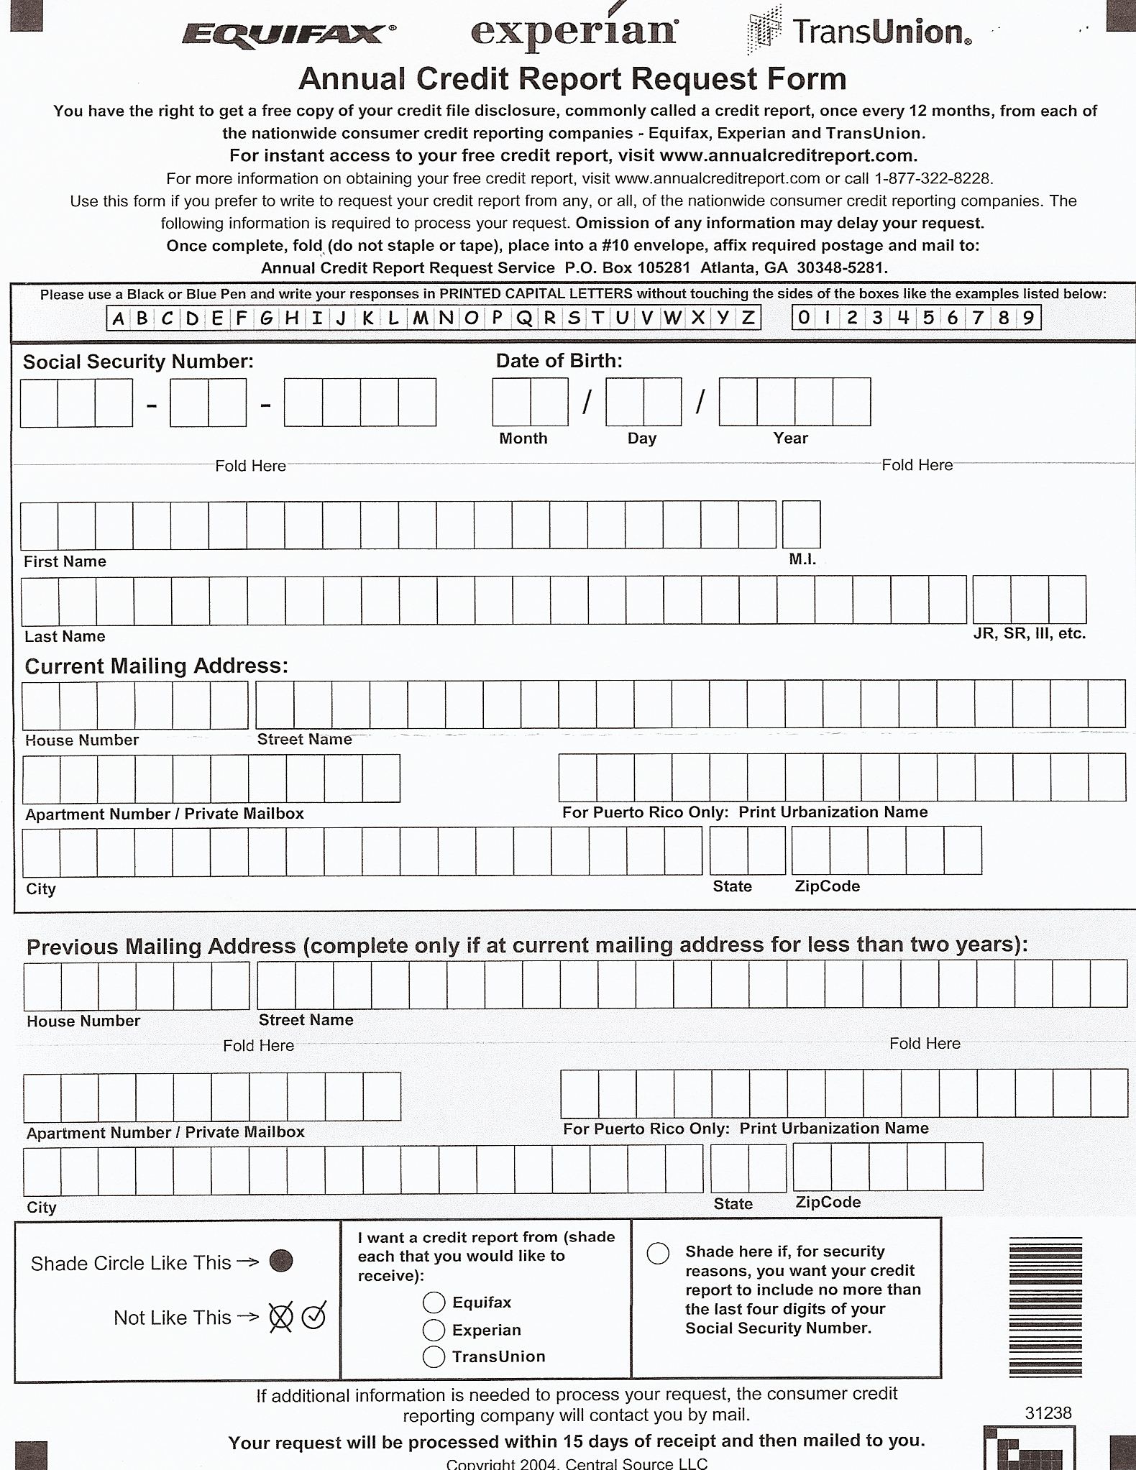

Security Freeze Letter - Equifax
Date:
Equifax Security Freeze
P.O. Box 105788
Atlanta, GA 30348

Dear Equifax:
I would like to place a security freeze on my credit file.
My full name is:
My current home address is:
My former home address is:
My Social Security number is:
My date of birth is:
As a proof of residence, I have enclosed a copy of my ____________ utility bill from ____________ (Date on Bill)
I will pay the fee of $10 for placing the freeze by check number __________.
Yours truly,

Sign Here ____________________
Your Name
Your Address
Your Home Phone
Your Work Phone

Security Freeze Letter - Experian

Date:
Experian Security Freeze
P.O. Box 9554
Allen, TX 75013
Dear Equifax:
I would like to place a security freeze on my credit file.
My full name is:
My current home address is:
My former home address is:
My Social Security number is:
My date of birth is:
As a proof of residence, I have enclosed a copy of my ____________ utility bill from ________________ (Date on Bill)
I will pay the fee of $10 for placing the freeze by check number __________.
Yours truly,

Sign Here ____________________
Your Name
Your Address
Your Home Phone
Your Work Phone

Security Freeze Letter - TransUnion
Date:
Trans Union Security Freeze
P.O. Box 6790
Fullerton, CA 92834-6790

Dear TransUnion:
I would like to place a security freeze on my credit file.
My full name is:
My current home address is:
My former home address is:
My Social Security number is:
My date of birth is:
As a proof of residence, I have enclosed a copy of my ____________ utility bill from ____________ (Date on Bill)
I will pay the fee of $10 for placing the freeze by check number __________.
Yours truly,

Sign Here ____________________
Your Name
Your Address
Your Home Phone
Your Work Phone

Sample Dispute Letter - Big 3 Credit Reporting Agencies

Date
Name
Your Address,
City, State, Zip Code

Complaint Department
Name of Company
Address
City, State, Zip Code

Dear Sir or Madam:
I am writing to dispute the following information in my file. I have circled the items I dispute on a attached copy of the report I received.

This item (identify item(s) disputed by name of source, such as creditors or tax court, and identify type of item, such as credit account, judgment, etc.) is (inaccurate or incomplete) because (describe what is inaccurate or incomplete and why). I am requesting that the item be removed (or request another specific change) to correct the information.

Enclosed are copies of (use this sentence if applicable and describe any enclosed documentation, such as payment records and court documents) supporting my position. Please reinvestigate this (these) matter(s) and (delete or correct) the disputed item(s) as soon as possible.
Sincerely,
Your name
Enclosures: (List what you are enclosing.)

SAMPLE BLOCKING LETTER - CONSUMER REPORTING COMPANY

Date

Your Name Your Address
Your City, State, Zip Code

Complaint Department
Name of Consumer Reporting Company Address
City, State, Zip Code

Dear Sir or Madam:

I am a victim of identity theft. I am writing to request that you
block the following fraudulent information in my file. This information does not relate to any transaction that I have made. The items also are circled on the attached copy of the report I received. (Identify item(s) to be blocked by name of source, such as creditors or tax court, and identify type of item, such as credit account, judgment, etc.)

Enclosed is a copy of the law enforcement report regarding my identity theft. Please let me know if you need any other information from me to block this information on my credit report.

Sincerely,

Your Name

Enclosures: (List what you are enclosing.)

Last Page of Manual

BLANK

